1. Enable EI web service logs

1. Open X:\ProgramData\HP\ALM\webapps\qcbin\WEB-INF\classes\log4j.properties,

2. Add or uncomment the following definitions and restart ALM service.

# Settings for CXF

log4j.logger.org.apache.cxf=DEBUG, CONSOLE, QcLogAppender

log4j.logger.org.apache.ws=DEBUG, CONSOLE, QcLogAppender

# Settings for EI

log4j.logger.com.hp.ei=DEBUG, CONSOLE, QcLogAppender

log4j.logger.com.hp.erp=DEBUG, CONSOLE, QcLogAppender

1. Set QC and SA logs to debug mode.

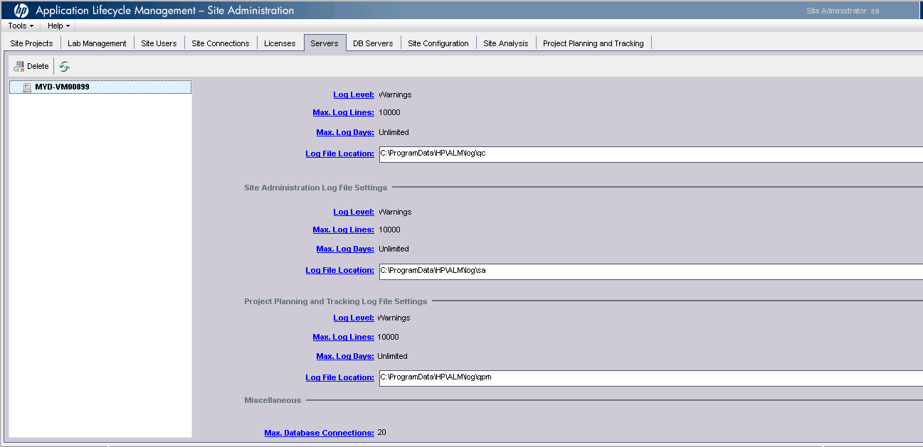

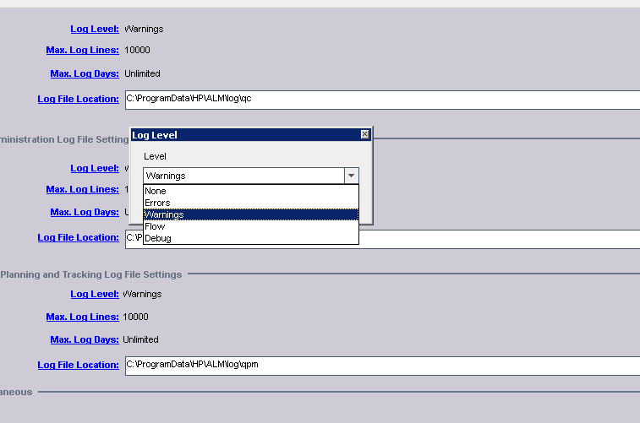

2. Reproduce the issue.

3. Provide QC, SA and wrapper logs, besides the date and time when the issue was reproduced